This Covenant Calendar for 2021 is a Melchizedek “Blood-Ratified” calendar that follows the detailed instructions from the Torah – with witnesses in the Old Testament and the Gospel letters. To make navigation easier, it is overlaid upon the Roman Gregorian Calendar. Use this to mark the annual Feast & Festival appointed and sacred times and “come up” to meet your High Priest for a special blessing.

Sponsored by members of the Covenant Calendar Club around the world!

For further studies & to sign up for weekly live/zoom meetings please visit:
www.studythecalendar.com
to enjoy many presentations in video, power point slideshow,
or download the PDFs for reading.
Weekly “live” zoom instruction by:
Tim Astleford & Charlene Fortsch
(including Covenant Calendar members)

Counting Covenant Calendar
Gregorian 1st Month January 2021
1st Cycle | 2nd Cycle | 3rd Cycle | 4th Cycle | 5th Cycle | 6th Cycle | Shabbat

Shanah  [Year]  10th Month  11th Month | 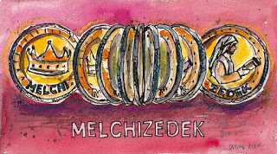 |  |  | Psalm 110:4  יהוה has sworn and does not relent, “YOU are a priest forever According to the order of Malkitseḏeq.” |  | 1  18th DAY  288/360 | 2  19th DAY  289/360
3  20th DAY  290/360 | 4  21st DAY  291/360 | 5  22nd DAY  292/360 | 6  23rd DAY  293/360 |  | 7  24th DAY  294/360 | 8  25th DAY  295/360 | 9  26th DAY  296/360
10  27th DAY  297/360 | 11  28th DAY  298/360 | 12  29th DAY  299/360 | 13  30th DAY  300/360 |  | 14  11th Month  1st DAY  301/360 | 15  2nd DAY  302/360 | 16  3rd DAY  303/360
17  4th DAY  304/360 | 18  5th DAY  305/360 | 19  6th DAY  306/360 | 20  7th DAY  307/360 |  | 21  8th DAY  308/360 | 22  9th DAY  309/360 | 23  10th DAY  310/360
24  11th DAY  311/360 | 25  12th DAY  312/360 | 26  13th DAY  313/360 | 27  14th DAY  314/360 |  | 28  15th DAY  315/360 | 29  16th DAY  316/360 | 30  17th DAY  317/360
31  18th DAY  318/360 | “Have I not commanded you? Be strong and courageous. | Do not be afraid, nor be discouraged,  for יהוה | your Elohim is with you wherever you go.”  Joshua 1:9 |  | Remember well what יהוה your Elohim | did to Pharaoh and to all Mitsrayim,  Deut. 7:18 | “Be strong and courageous.”  Deut. 31:6
Counting Covenant Calendar
Gregorian 2nd Month February 2021
1st Cycle | 2nd Cycle | 3rd Cycle | 4th Cycle | 5th Cycle | 6th Cycle | Shabbat

Shanah  [Year]  11th Month  12th Month | 1  19th DAY  319/360 | 2  20th DAY  320/360 | 3  21st DAY  321/360 | 4  22nd DAY  322/360 | 5  23rd DAY  323/360 | 6  24th DAY  324/360
7  25th DAY  325/360 | 8  26th DAY  326/360 | 9  27th DAY  327/360 | 10  28th DAY  328/360 | 11  29th DAY  329/360 | 12  30th DAY  330/360 | 13  12th Month  1st DAY  331/360
14  2nd DAY  332/360 | 15  3rd DAY  333/360 | 16  4th DAY  334/360 | 17  5th DAY  335/360 | 18  6th DAY  336/360 | 19  7th DAY  337/360 | 20  8th DAY  338/360
21  9th DAY  339/360 | 22  10th DAY  340/360 | 23  11th DAY  341/360 | 24  12th DAY  342/360 | 25  13th DAY  343/360 | 26  14th DAY  344/360 | 27  15th DAY  345/360
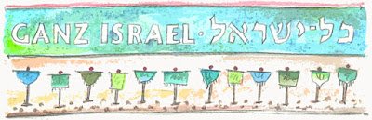  28  16th DAY  346/360 | Please join us live each week as we study the scripture together online go to www.studythecalendar.com and sign up for the free weekly email and zoom logo in details.
Counting Covenant Calendar
Gregorian 3rd Month March 2021

1st Cycle | 2nd Cycle | 3rd Cycle | 4th Cycle | 5th Cycle | 6th Cycle | Shabbat

Shanah  [Year]  12th Month  1st Month | 1  17th DAY  347/360 | 2  18th DAY  348/360 | 3  19th DAY  349/360 | 4  20th DAY  350/360 | 5  21st DAY  351/360 | 6  22nd DAY  352/360
7  23rd DAY  353/360 | 8  24th DAY  354/360 | 9  25th DAY  355/360 | 10  26th DAY  356/360 | 11  27th DAY  357/360 | 12  28th DAY  358/360 | 13  29th DAY  359/360
14  30th DAY  360/360 | 15  Balancing  Days | 16  Balancing  Days | 17  Balancing  Days | 18  Balancing  Days | 19  Balancing  Days | 20  Tequfah
21  1st Month  1st DAY  1/360 | 22  2nd DAY  2/360 | 23  3rd DAY  3/360 | 24  4th DAY  4/360 | 25  5th DAY  5/360 | 26  6th DAY  6/360 | 27  7th DAY  7/360
28  8th DAY  8/360 | 29  9th DAY  9/360 | 30  10th DAY  10/360 | 31  11th DAY  11/360 | “I am the ‘Aleph’ and the ‘Taw’, the First and the Last,” | “who is and who was and who is to come,  El Shaddai  Rev. 1:8 | 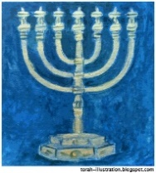
Counting Covenant Calendar
Gregorian 4th Month April 2021
1st Cycle | 2nd Cycle | 3rd Cycle | 4th Cycle | 5th Cycle | 6th Cycle | Shabbat

Shanah  [Year]  1st Month  2nd Month | 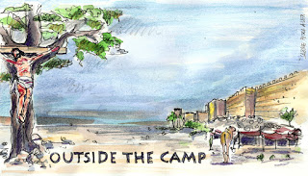 |  |  | 1  12th DAY  12/360 | 2  13th DAY  13/360 | 3  14th DAY  14/360  Passover
4  15th DAY  15/360  1st DAY of  Unleavened  Bread  Wave Sheaf  Omer 1 | 5  16th DAY  16/360  2nd DAY of  Unleavened  Bread  Omer 2 | 6  17th DAY  17/360  3rd DAY of  Unleavened  Bread  Omer 3 | 7  18th DAY  18/360  4th DAY of Unleavened  Bread  Omer 4 | 8  19th DAY  19/360  5th DAY of  Unleavened  Bread  Omer 5 | 9  20th DAY  20/360  6th DAY of  Unleavened  Bread  Omer 6 | 10  21st DAY  21/360  7th DAY of  Unleavened  Bread  Omer 7
11  22nd DAY  22/360  Omer 8 | 12  23rd DAY  23/360  Omer 9 | 13  24th DAY  24/360  Omer 10 | 14  25th DAY  25/360  Omer 11 | 15  26th DAY  26/360  Omer 12 | 16  27thDAY  27/360  Omer 13 | 17  28th DAY  28/360  Omer 14
18  29th DAY  29/360  Omer 15 | 19  30th DAY  30/360  Omer 16 | 20  2nd Month  1st DAY  31/360  Omer 17 | 21  2nd DAY  32/360  Omer 18 | 22  3rd DAY  33/360  Omer 19 | 23  4th DAY  34/360  Omer 20 | 24  5th DAY  35/360  Omer 21
25  6th DAY  36/360  Omer 22 | 26  7th DAY  37/360  Omer 23 | 27  8th DAY  38/360  Omer 24 | 28  9th DAY  39/360  Omer 25 | 29  10th DAY  40/360  Omer 26 | 30  11th DAY  41/360  Omer 27 | 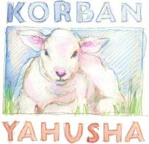
Counting Covenant Calendar
Gregorian 5th Month May 2021

1st Cycle | 2nd Cycle | 3rd Cycle | 4th Cycle | 5th Cycle | 6th Cycle | Shabbat

Shanah  [Year]  2nd Month  3rd Month | 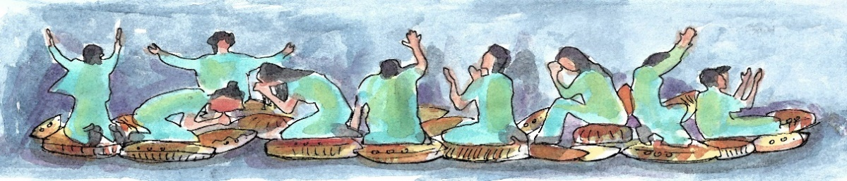 |  |  |  |  |  |  | 1  12th DAY  42/360  Omer 28
2  13th DAY  43/360  Omer 29 |  | 3  14th DAY  44/360  Omer 30 | 4  15th DAY  45/360  Omer 31 | 5  16th DAY  46/360  Omer 32 | 6  17th DAY  47/360  Omer 33 | 7  18th DAY  48/360  Omer 34 | 8  19th DAY  49/360  Omer 35
9  20th DAY  50/360  Omer 36 |  | 10  21st DAY  51/360  Omer 37 | 11  22nd DAY  52/360  Omer 38 | 12  23rd DAY  53/360  Omer 39 | 13  24th DAY  54/360  Omer 40 | 14  25th DAY  55/360  Omer 41 | 15  26th DAY  56/360  Omer 42
16  27th DAY  57/360  Omer 43 |  | 17  28th DAY  58/360  Omer 44 | 18  29th DAY  59/360  Omer 45 | 19  30th DAY  60/360  Omer 46 | 20  3rd Month  1st DAY  61/360  Omer 47 | 21  2nd DAY  62/360  Omer 48 | 22  3rd DAY  63/360  Omer 49
23  Shavuot  4th DAY  64/360  Omer 50 |  | 24  5th DAY  65/360 | 25  6th DAY  66/360 | 26  7th DAY  67/360 | 27  8th DAY  68/360 | 28  9th DAY  69/360 | 29  10th DAY  70/360
30  11th DAY  71/360 |  | 31  12th DAY  72/360 |  | 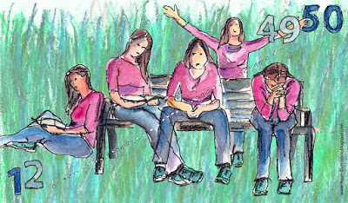 |  | 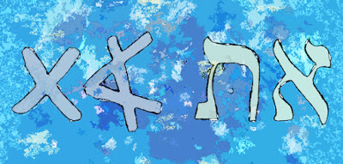 | “I am the ‘Aleph’ and the ‘Taw’  Beginning and End,” says יהוה
Counting Covenant Calendar
Gregorian 6th Month June 2021
1st Cycle | 2nd Cycle | 3rd Cycle | 4th Cycle | 5th Cycle | 6th Cycle | Shabbat

Shanah  [Year]  3rd Month  4th Month | 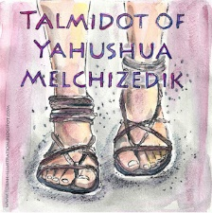 | 1  13th DAY  73/360 | 2  14th DAY  74/360 | 3  15th DAY  75/360 | 4  16th DAY  76/360 | 5  17th DAY  77/360
6  18th DAY  78/360 | 7  19th DAY  79/360 | 8  20th DAY  80/360 | 9  21st DAY  81/360 | 10  22nd DAY  82/360 | 11  23rd DAY  83/360 | 12  24th DAY  84/360
13  25th DAY  85/360 | 14  26th DAY  86/360 | 15  27th DAY  87/360 | 16  28th DAY  88/360 | 17  29th DAY  89/360 | 18  30th DAY  90/360 | 19  4th Month  1st DAY  91/360
20  2nd DAY  92/360 | 21  3rd DAY  93/360 | 22  4th DAY  94/360 | 23  5th DAY  95/360 | 24  6th DAY  96/360 | 25  7th DAY  97/360 | 26  8th DAY  98/360
27  9th DAY  99/360 | 28  10th DAY  100/360 | 29  11th DAY  101/360 | 30  12th DAY  102/360 | 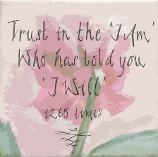 | אֶֽהְיֶ֖ה  I AM
Counting Covenant Calendar
Gregorian 7th Month July 2021

1st Cycle | 2nd Cycle | 3rd Cycle | 4th Cycle | 5th Cycle | 6th Cycle | Shabbat

Shanah  [Year]  4th Month  5th Month | 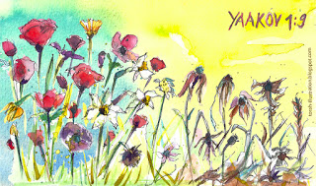 |  |  | 1  13th DAY  103/360 | 2  14th DAY  104/360 | 3  15th DAY  105/360
4  16th DAY  106/360 | 5  17th DAY  107/360 | 6  18th DAY  108/360 | 7  19th DAY  109/360 | 8  20th DAY  110/360 | 9  21st DAY  111/360 | 10  22nd DAY  112/360
11  23rd DAY  113/360 | 12  24th DAY  114/360 | 13  25th DAY  115/360 | 14  26th DAY  116/360 | 15  27th DAY  117/360 | 16  28thDAY  118/360 | 17  29th DAY  119/360
18  30th DAY  120/360 | 19  5th Month  1st DAY  121/360 | 20  2nd DAY  122/360 | 21  3rd DAY  123/360 | 22  4th DAY  124/360 | 23  5th DAY  125/360 | 24  6th DAY  126/360
25  7th DAY  127/360 | 26  8th DAY  128/360 | 27  9th DAY  129/360 | 28  10th DAY  130/360 | 29  11th DAY  131/360 | 30  12th DAY  132/360 | 31  13th DAY  133/360

Counting Covenant Calendar
Gregorian 8th Month August 2021

1st Cycle | 2nd Cycle | 3rd Cycle | 4th Cycle | 5th Cycle | 6th Cycle | Shabbat

Shanah  [Year]  5th Month  6th Month | 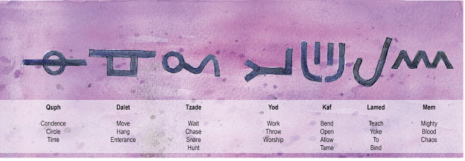 |  |  | Hebrews 6:20  יהושע  has entered as a forerunner for us,  having become High Priest forever  according to the order of Malkitseḏeq.
1  14th DAY  134/360 | 2  15th DAY  135/360 | 3  16th DAY  136/360 | 4  17th DAY  137/360 | 5  18th DAY  138/360 | 6  19th DAY  139/360 | 7  20th DAY  140/360
8  21st DAY  141/360 | 9  22nd DAY  142/360 | 10  23rd DAY  143/360 | 11  24th DAY  144/360 | 12  25th DAY  145/360 | 13  26th DAY  146/360 | 14  27th DAY  147/360
15  28th DAY  148/360 | 16  29th DAY  149/360 | 17  30th DAY  150/360 | 18  6th Month  1st DAY  151/360 | 19  2nd DAY  152/360 | 20  3rd DAY  153/360 | 21  4th DAY  154/360
22  5th DAY  155/360 | 23  6th DAY  156/360 | 24  7th DAY  157/360 | 25  8th DAY  158/360 | 26  9th DAY  159/360 | 27  10th DAY  160/360 | 28  11th DAY  161/360
29  12th DAY  162/360 | 30  13th DAY  163/360 | 31  14th DAY  164/360 | 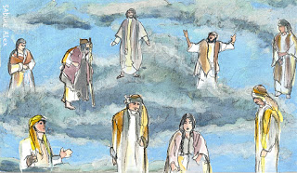
Counting Covenant Calendar
Gregorian 9th Month September 2021

1st Cycle | 2nd Cycle | 3rd Cycle | 4th Cycle | 5th Cycle | 6th Cycle | Shabbat

Shanah  [Year]  6th Month  7th Month | 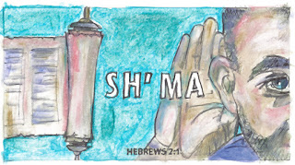 |  | 1  15th DAY  165/360 | 2  16th DAY  166/360 | 3  17th DAY  167/360 | 4  18th DAY  168/360
5  19th DAY  169/360 | 6  20th DAY  170/360 | 7  21st DAY  171/360 | 8  22nd DAY  172/360 | 9  23rd DAY  173/360 | 10  24th DAY  174/360 | 11  25th DAY  175/360
12  26th DAY  176/360 | 13  27th DAY  177/360 | 14  28th DAY  178/360 | 15  29th DAY  179/360 | 16  30th DAY  180/360 | 17  7th Month  1st DAY  181/360  Feast of  Trumpets | 18  2nd DAY  182/360
19  3rd DAY  183/360 | 20  4th DAY  184/360 | 21  5th DAY  185/360 | 22  6th DAY  186/360 | 23  7th DAY  187/360 | 24  8th DAY  188/360 | 25  9th DAY  189/360
26  10th DAY  190/360  Yom  Kippur | 27  11th DAY  191/360 | 28  12th DAY  192/360 | 29  13th DAY  193/360 | 30  14th DAY  194/360 |  | “Do not be afraid,  I AM  THE First and THE Last.”

Counting Covenant Calendar
Gregorian 10th Month October 2021

1st Cycle | 2nd Cycle | 3rd Cycle | 4th Cycle | 5th Cycle | 6th Cycle | Shabbat

Shanah  [Year]  7th Month  8th Month | 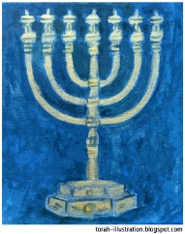 | THE  WORD  became Flesh/Basar and | pitched  HIS SUKKAH  among us.  [John]  Yohanaan 1:14 |  | 1  15th DAY  195/360  Sukkot/  Tabernacles | 2  16th DAY  196/360
3  17th DAY  197/360 | 4  18th DAY  198/360 | 5  19th DAY  199/360 | 6  20th DAY  200/360 | 7  21st DAY  201/360 | 8  22nd DAY  202/360  The LAST Great DAY | 9  23rd DAY  203/360
10  24th DAY  204/360 | 11  25th DAY  205/360 | 12  26th DAY  206/360 | 13  27th DAY  207/360 | 14  28th DAY  208/360 | 15  29th DAY  209/360 | 16  30th DAY  210/360
17  8th Month  1st DAY  211/360 | 18  2nd DAY  212/360 | 19  3rd DAY  213/360 | 20  4th DAY  214/360 | 21  5th DAY  215/360 | 22  6th DAY  216/360 | 23  7th DAY  217/360
24  8th DAY  218/360 | 25  9th DAY  219/360 | 26  10th DAY  220/360 | 27  11th DAY  221/360 | 28  12th DAY  222/360 | 29  13th DAY  223/360 | 30  14th DAY  224/360
31  15th DAY  225/360 |  |  |  | John 7:37 And on the last day, the great day of the festival, יהושע stood and cried out, saying, | “If anyone thirsts, let him come to Me, and let him who believes in Me drink. | John 7:38 “As the Scripture said, out of His innermost shall flow rivers of living water.”  ISR 1998

Counting Covenant Calendar
Gregorian 11th Month November 2021

1st Cycle | 2nd Cycle | 3rd Cycle | 4th Cycle | 5th Cycle | 6th Cycle | Shabbat

Shanah  [Year]  8th Month  9th Month | 1  16th DAY  226/360 | 2  17th DAY  227/360 | 3  18th DAY  228/360 | 4  19th DAY  229/360 | 5  20th DAY  230/360 | 6  21st DAY  231/360
7  22nd DAY  232/360 | 8  23rd DAY  233/360 | 9  24th DAY  234/360 | 10  25th DAY  235/360 | 11  26th DAY  236/360 | 12  27th DAY  237/360 | 13  28th DAY  238/360
14  29th DAY  239/360 | 15  30th DAY  240/360 | 16  9th Month  1st DAY  241/360 | 17  2nd DAY  242/360 | 18  3rd DAY  243/360 | 19  4th DAY  244/360 | 20  5th DAY  245/360
21  6th DAY  246/360 | 22  7th DAY  247/360 | 23  8th DAY  248/360 | 24  9th DAY  249/360 | 25  10th DAY  250/360 | 26  11th DAY  251/360 | 27  12th DAY  252/360
28  13th DAY  253/360 | 29  14th DAY  254/360 | 30  15th DAY  255/360 | 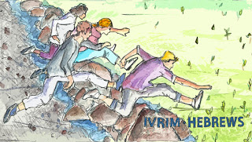 |  | 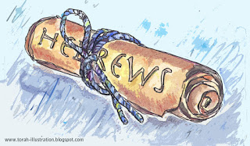
Counting Covenant Calendar
Gregorian 12th Month December 2021

1st Cycle | 2nd Cycle | 3rd Cycle | 4th Cycle | 5th Cycle | 6th Cycle | Shabbat

Shanah  [Year]  9th Month  10th Month |  |  | 1  16th DAY  256/360 | 2  17th DAY  257/360 | 3  18th DAY  258/360 | 4  19th DAY  259/360
5  20th DAY  260/360 | 6  21st DAY  261/360 | 7  22nd DAY  262/360 | 8  23rd DAY  263/360 | 9  24th DAY  264/360 | 10  25th DAY  265/360 | 11  26th DAY  266/360
12  27th DAY  267/360 | 13  28th DAY  268/360 | 14  29th DAY  269/360 | 15  30th DAY  270/360 | 16  10th Month  1st DAY  271/360 | 17  2nd DAY  272/360 | 18  3rd DAY  273/360
19  4th DAY  274/360 | 20  5th DAY  275/360 | 21  6th DAY  276/360 | 22  7th DAY  277/360 | 23  8th DAY  278/360 | 24  9th DAY  279/360 | 25  10th DAY  280/360
26  11th DAY  281/360 | 27  12th DAY  282/360 | 28  13th DAY  283/360 | 29  14th DAY  284/360 | 30  15th DAY  285/360 | 31  16th DAY  286/360 | Figure 1Exodus 19:5  Figure 2Exodus 19:5

