Shalom and Boker tov/Good morning, Stacy and family!!!
Sis, you made a final remark about using the name 'Jesus' (saying that you realize this is, doubtless, a bigger discussion for maybe another time), and sis Charlene asked me something along the lines of, "Did that answer help" me, and also (if I remember rightly) she asked whether anyone on the panel wanted to reply/had any feedback.
I chose not to respond then, deferring to the panel, because I wanted time to think about your comment and prayerfully consider my response.
I am responding now because it's fresh on my mind, having had time with Him this first-day-of-the-week morning ... and it may not be (lol) by the time we are together again on panel. If invited then (the next time the greater family is online together and the discussion is raised) to share this, I will.
But the hour cometh, and now is, when the true worshippers shall worship the Father in spirit and in truth: for the Father seeketh such to worship Him. El is Spirit: and they that worship Him must worship Him in spirit and in truth. (John 4:23-24)
We read here that worshippers of Elohim must do so in spirit and in truth, and as I understand it, the name 'Jesus' is such a tragic departure from-- and void of/bankrupt in-- the truth that I cannot use it in prayer at the stage I am in my journey today.
Many of us already know about the failure it is as a TRANSLATION. As such, in the plainest sense, it's just not His name.

My nickname is 'Eddie.' When someone says it, my ear hears. When I hear someone call out "Edwidge" (pronounced eh DWEEJ), my heart hears because that's the name my parents gave me; the person who uses that name knows me in a different, more intimate way. Still 'Eddie' is a nickname I give readily for myself, and I will answer without hesitation to it-- even just E, which I'm also called.
I will not respond to ... say ... 'Hedwig,' though (as I understand it) it is the Germanic form of my name. I'm not German. Neither are my parents. That is not the name they gave me. It's not my name. I would kindly correct the person.
How might I feel then, I wonder, if after learning my real name, the person kept calling me 'Hedwig' or just 'Miss'? How would I feel if he/she continues to tell others my name is Hedwig? How might I feel if others who call me Hedwig are not corrected by those who know my name to be Edwidge-- no matter whether or not they accept my true name? Sincere questions for all of us to consider ...
Note that I said that I cannot pray in that name; having a discussion with another who does not know or understand the true Name, however, is a different matter, I think.
I can and will, if need be, use the name in that context for the purpose facilitating what I hope will be fruitful and transforming conversation. THIS is an example, for me, of where "meeting people where they are" comes into play. I will meet them there, but I won't 'set up camp' (lol), if you will, meaning I will be understanding/considerate and compassionate concerning where they are in their journey (non-reactive when they use the name 'Jesus' ... or Jesu or Jezi or Hesu ...), but I will use the true Name and be prepared to gently and lovingly (with the Spirit's help) explain why if they ask.
The Name-- being pregnant with meaning, as I said before-- is arrestingly weighty and of profound consequence. Its concealment is no small matter. And I think it loving to introduce professed believers to the truth and awe of It whenever possible rather than-- however well-meaning-- unintentionally endorse (in a sense) its obscurity among those who want to grow in knowledge of and love toward Him.
For me, the remark that I shared with the panel yesterday ("Many of us upholding Torah in Messiah would not have come to know Yahusha if we did not first come to know 'Jesus'") serves, powerfully, to help me relate to others in love, patience, and understanding, remembering when and how I myself started. It is not permission (again, I speak for myself), however, to return to my erroneous and dimmer beginnings, no matter how valuable these clumsy beginnings were as a life-changing introduction and step toward reconciliation with the Father and everlasting life in His Messiah Son.
Does that make sense?
Now, if the person with whom I'm speaking is offended by the true Name of Messiah, bristles, opposes/rejects, and departs, the question must be asked-- through tears even-- "Have I now become your enemy by telling you the truth?" (Gal 4:16) Who has been unloving (in this case)? And of greater consideration ... unloving toward Whom?
I say His Name because I love HIM, not because I don't love the person sitting or standing across from me.
I can no longer PRAY in that name and prefer not to use the name 'Jesus' but am willing to seek some common ground with those who are yet where I certainly was-- because HE was MERCIFUL toward me ... YaH-forbid I would withhold mercy and tenderness from another (though, I'm sure a number of these would be offended at the suggestion that they're 'missing something' we have, lol ... aaaahhhh whattayagonna do, eh?). ELOHIM is the One Who brought us to the place we are now and not we ourselves; we mustn't forget our starting place, true-- neither, however, should we hold to any error that we acquired there (from that start).
Forgive me, I know this email is ridiculously long already, but if you give me just a little bit more of your time ... I had an illustration I wrote years ago in some journal ... that I CAN'T find! lol
BUT I think I remember it well enough to convey the gist ...
There I was, reveling in my rebellion, going unabated in my condition and status as an enemy of Elohim; and as I did so, I danced closer and closer toward the end of utter destruction ... death and darkness forevermore.
My crimes were vile and endless, though I hadn't thought so because I my eyes were fixed on the next guy's rap sheet. Since he seemed 'so much worse,' I failed to grasp how far my 'not much better' was from the perfect standard.
But standing there, before Perfection, I saw my crimes afresh. I heard them and smelled them and tasted them, and it was near unbearable to view these crimes in the Light of the Perfection from which I was so distant-- these crimes against this perfect, set-apart One whom all of Creation knowingly worships and to whom all of Creation harmoniously submits, save audacious Man!
And I was humbled and laid bare. I could not deny, neither could I hide.
And at the moment my penalty was due, in came One to offer Himself in my stead. I beheld the full weight of my sin set upon Him. He bore it. All of it. And that of all the others in that moment. Right then.
And I was released.
I asked desperately, "Who is that Man?! What's His name, please?!"
I was told, "His name is Jesus."
"How may I know more about Him?!"
I was given a book.
And I loved Him ... how I loved Him. I lived to honor this Savior of my soul ... but
one, I didn't really read the book;
two, I preferred that others should explain to me what was in the book; and
three, it didn't occur to me that this book, in my language, distanced me, in a sense, from all that He had to say to me in His (language).
He meant everything to me, so, in time though, I pressed ... and pressed ... as His Spirit led and helped me. And among the truths I learned was His actual Name.
Yes, I loved Him as 'Jesus,' but now I could love and KNOW all the better Him as Yahusha/Yahushua, this name that DECLARES His identity and purpose/work in the Most High YaH.

When Kefa said there is "no other name ...", that includes 'Jesus,' which is another name, in my present view:
This Yahusha/Yahushua ('YaH delivers/saves'-'YaH is 'deliverance/salvation') is ‘the stone you builders rejected, which has become the cornerstone.’ Deliverance/Salvation exists in no one else, for there is no other name under heaven given to men by which we must be saved.” (Acts 4: 11-12)
As we grow in Him, we ought to walk progressively in the truth we know from Him.
Alrighty, there you have it, beloved family ... my two-- er, maybe 200? -- cents. (Oy. My bad ... )
I appreciate your final comment yesterday, sis Stacy, and your encouragement, and that deeply stirring presentation you shared with us so, so very much. While I personally cannot, at this point, pray in conviction and shalom in the name of 'Jesus,' I can and am willing use/refer to the name, if need be, in conversation as a bridge to the truth, in love and understanding. I do not take away from the perspective you shared or the place where you are; I accept and respect it. He is refining and perfecting us all by His Spirit: Shoulder to shoulder, let's finish strong!

Grace, Shalom & Philia~

Personal email message from Sis. Eddie to a limited number of members of the CCC family (due to saved contact info, not partiality. I love you all!)
TIME STAMP: Sun, May 22 at 8:46 AM
Shalom Shalom! Boker tov family/mishpocha!
So ... like many/most of you ... I went from "Jesus" to "Yeshua" to "Yahshua" and presently say, mostly, "Yahushua." I have noticed however that a number of my brothers and sisters have recently (within the last 5 years or so, give or take) have begun to say "Yahusha," and I wondered ...
Why?
What marked THIS change?
Where did this pronunciation come from? …
(I’d attached a doc that presents TWO (2) sources that helped me arrive at my present understanding on the matter-- one that advocates for the YAHUSHA pronunciation and the other for the YAHUSHUA one.)
Taken TOGETHER, though, they have helped me to see that BOTH pronunciations are correct/right and appropriate: It's simply a matter of SENTENCE PATTERN—
S Vi (subject - verb-intransitive) versus
S Vl PN (subject - verb-linking - predicate noun)
YAHUSHA reflects the first sentence pattern: YaHU SAVES/DELIVERS (emphasizing the action verb— what He DOES) ... whereas ...
YAHUSHUA reflects the second sentence pattern: YaHU IS SALVATION/DELIVERANCE (emphasizing the verb of being and predicate noun— what He IS)!
That's it!
Of course, BOTH are true! HalleluYaH!
So, one's preference between the two, I guess, just comes down to his/her desired emphasis in any given moment that said believer is uttering His name! In saying His name at any particular moment, is the focus of your heart on what He does or on what He is? ... Again— that's it!
What a blessed way to start the first day of the week, eh?!
Well, if anyone decides to check out what's presented in the attachment, I'd love to hear your thoughts. …

Oh!!!, by the way, the other thing that one or both of the articles bear out is the horrible thing that it appears we may be saying when we say "Yeshua," with the "e" and without the hey/heh.

It is actually said to have derived from an ACRONYM representing wordS that are evil toward Messiah, rather than truly being a translated or transliterated proper name.

If true, that is a pretty scary thing ...

Grace, Shalom & Philia, family!

Personal email message from Sis. Eddie to a limited number of members of the CCC family (due to saved contact info, not partiality. I love you all!)
TIME STAMP: Sun, May 15 at 1:01 PM
What follows comes from three separate sources, of many, that I’ve consulted to supplement my Scriptural study and investigation into the Name of Messiah. The FULL texts are not represented here as I TRIED to keep this from become as long as it became ANYWAY! Lol I have, however, included links that will bring you the original articles that are INCLUDED below. I hope what I provide here will be a launching pad for those who are starting out on this journey of the Sacred Names. There’s loads of information out there, and it can be confusing and overwhelming, but trust Him. His Spirit will lead us into all truth. Our part is just to, at least, reach for it. Search in Shalom, family. Love in Messiah!

YESHUA OR YAHUSHUA

WHAT’S THE DIFFERENCE?
Some believers who are new to the concept that the Messiah has a Hebrew Name and some who look to the Jewish believers for truth wind up calling the Messiah – ‘Yeshua‘.
This article is not written to attack those who do so. Most of us have come from one denomination of christianity or another and have inherited many wrong doctrines… This article is written to clear up confusion for those who don’t understand why there is a difference, or indeed that there is a difference.
As it turns out there is very much indeed a difference and a very important difference at that!

The root of the difference lies in the problem with Jewish tradition… According to the pharisees and Talmudic teachers of law, the Name of the Almighty Creator – Yahweh is too ‘holy’ to pronounce. This ‘tradition’ goes against all Scripture commanding us to: Praise His Name (Psa 113:1)… Call on His Name (Psa 105:1)… Sing praises to His Name (Psa 61:8)… Bless in His Name (Deu 21:5)… Not to bring His Name to naught (Exo 20:7)… His Name is a remembrance (Exo 3:15) etc. see article below:
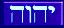

The Jewish tradition of not pronouncing the Name of Yahweh extends to the Name of the Messiah…
The Name of Yahweh is known as the ‘tetragrammaton’ (YHWH), meaning ‘four’ (tetra) ‘letters’ (gramma) amongst scholars and in Hebrew is spelled:
ה ו ה י
yod, hay, waw, hay
The Name of the Messiah in Hebrew is spelled: (read left to right for simplicity)
ע ש ו ה י
yod, hay, waw, shin, ayin
You will notice that the Messiah’s Name (like many in Scripture – Eliyahu – (My El is Yahweh), Yeshayahu– (Salvation of Yahweh) Nethanyahu – (given of Yahweh), Obadyahu – (servant of Yahweh), Mattithyahu -(Gift of Yahweh), etc… there are nearly 100) contains the first three letters of the Name of the Almighty –
ו ה י
yod, hay, waw
This is known as the ‘trigrammaton’ (YHW).
Because this trigrammaton is contained in the Name of the Messiah and the pharisaical tradition to not pronounce the Name, the Name of the Messiah is abbreviated to – Y’shua (pronounced Yeshua).

HE CAME IN HIS FATHER’S NAME
It will be quite obvious to you by now that by using the abbreviated form of the Name of the Messiah is in effect taking the Name of Yahweh out of the Name of the Son. Why would the prophets of Yahweh have His name in theirs and not the One and Only Son?
The Name of Yahushua means – ‘Yahuweh‘- (Yahu) ‘is salvation‘ (shua)
Matthew 1:21 “And she shall give birth to a Son, and you shall call His Name ע ש ו ה י for He shall save His people from their sins.”

Yahuweh proclaimed that He would have His Name:
Exo 23:21 “Be on guard before Him and obey His voice. Do not rebel against Him, for He is not going to pardon your transgression, for My Name is in Him.”

Yahushua also proclaimed that He came in His Father’s Name:
John 5:43 “I have come in My Father’s Name and you do not receive Me, if another comes in his own name, him you would receive.”
Joh 17:12 “When I was with them in the world, I was guarding them in Your Name which You have given Me…”

In its basic Hebrew sense, ‘Yeshua‘ simply means – ‘salvation‘, but if our Messiah said He came in His Father’s Name; who are we to remove it by tradition, or any other well-meaning reason?
There are approximately 90 names in Scripture that contain the ‘tri-grammaton’ – YAHU and a further 85 containing the Name YAH.
Here are some of the names of others with YAHU in them…
Adoniyahu (Adonijah) – “my Master is Yahuweh”
Azaryahu (Azariah) – “ Yahuweh is help”
Bereḵyahu (Berekiah) – “blessed of Yahuweh”
Gedalyahu (Gedaliah) – “Yahuweh is great”
Kenanyahu (Chenaniah) – “Yahuweh has planted”
Hananyahu (Hananiah) – “favoured of Yahuweh”
Mattanyahu (Mattaniah) – “gift of Yahuweh”
Pelatyahu (Petaliah) – “Yahuweh has delivered”
Semaḵyahu (Semakiah) – “Sustained of Yahuweh”
Shephatyahu (Shephatiah) – “Yahuweh has judged”

With all these men of Yahweh so favoured to have the Father insert His Name in theirs, He definitely placed His Name in His own Son’s Name, Yahushua (Yahuweh is salvation).
We will not be seeing HIM again unless we say He comes in His Father’s Name and call upon that Name (John 5:43)…

“For I say to you, from now on you shall by no means see Me, until you say, ‘Blessed is He who is coming in the Name of YHWH! (Mattithayahu 23:39)

WHAT ABOUT YAHUSHA?
A relatively new way that has been proposed to pronounce the Name of the Messiah, which they pronounce Yahusha.

It is commendable that people are at least trying to call the Messiah anything close, rather than “Jeezus,” but it only requires a little study to shoe that Yahushua is the FULL Name of the Messiah.

Many who are unfamiliar with the Biblical Hebrew language get confused over the construct of words and root words…
Root words as mentioned in Hebrew lexicons etc. are seldom used in that root form. They are typically constructed into compound words which take on various meanings depending on the particular construct…

eg. Yasha is the root word meaning ‘save’ which is used to make structured sentences.

Many fall into the trap of simply clicking on their Strong’s number in e-sword or the like and assume they instantly know Hebrew, yet when you read the Hebrew it is not so simple: Deut 20:4

“…for YHWH your Elohim is He who goes with you, to fight for you against your enemies, to save you.”
כי יהוה אלהיכם ההלך עמכם להלחם לכם עם־איביכם ע י שׁ ו ה ל אתכם׃
(This flipped in Word.)

You will notice the construct is ‘lehoshia’, the ‘save’ (yasha) becoming ‘shia’

On the other hand ‘salvation’ or deliverance takes on a recognizable form:
“I have waited for your deliverance, O YHWH!”
ך ת ע ו שׁ י ל קויתי יהוה׃
(This flipped in Word.)

The construct is ‘lishuatekha’, the salvation written as ‘shua’

So when the Meshiach’s Name is written in full: עושׁוהי it means ‘YHWH is salvation’ rather than ‘YHWH saves’.

As we have written previously, many names in Scripture utilize the exact spelling and construct for ‘salvation’, eg:
Elishua (the full form of Elisha), Malkishua, Abishua, Bathshua, Yeshua and of course Yahoshua all take on the same form: shua – עושׁ

We simply cannot ignore all these other usages and so many names of other individuals in Scriptures just to entertain a relatively new concept of the pronunciation of a Name in Scripture.

Look into the term ‘defective spelling’ then examine the DSS and you will find at least another 8. This is what scholars know of as there are yet many hundreds of thousands of fragments from Qumran that are still yet to be revealed…

Dawid’s name is missing the yod nearly half the appearances in scripture and nearly all of the individuals in Scripture whose names end with the Trigrammaton drop the waw on many appearances.

Strong’s only shows the root word for a given word or name eg the word ‘yasha’ which many Yahusha proponents use as an example but this never appears in Scripture…

What needs to be focused on is the root word ‘y’shua’ (Strong’s 3444), which means ‘salvation’ or ‘deliverance’ and in construct always appears with the waw.

We have the witness of Yĕshua whose name appears 30 times that the correct grammatical pronunciation is with the waw. Elishua (the full form of Elisha), Malkishua, Abishua, Bathshua all appear with or without the waw.

Just to prove that the waw is indeed part of Yahshua’s Name is this image of an engraved plate placed in the Shrine of the Scroll in state of Israel. You can go down the stairs and look at it yourself…

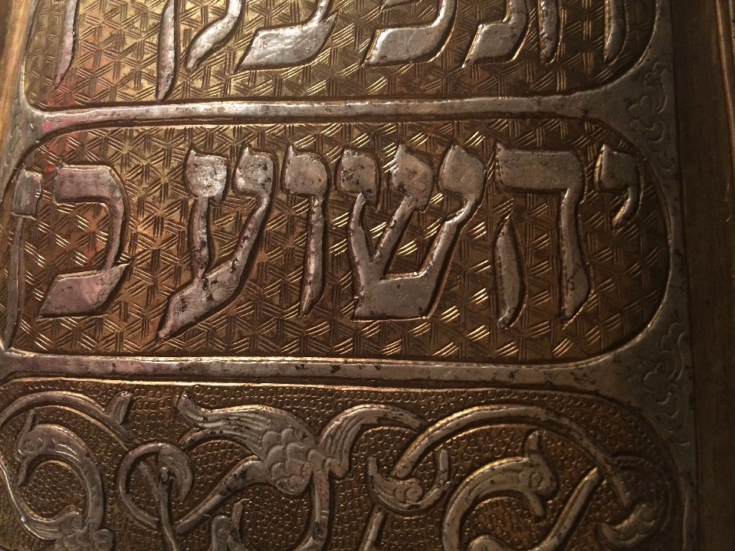

https://2besaved.com/2bsyeshua/
*********************************************************

Where Do We Get “Yahusha” From As The Name Of The Son Of Yahuah?
Yahusha, alt. YEHOSHUA, YAHUSHUA, YESHUA
On or about 9-25-06, the article/topic Yahusha was deleted from Wikipedia, apparently for “raving.” Even one complaint can remove any article from their site, so obviously someone complained and cited the article for removal for raving. You can read the article for yourself to evaluate the level of raving you detect in it. It’s very interesting that Yahusha predicted that we would be persecuted and suffer for His Name (Luke 21:12), and that people would readily accept another in their own name.
Yahusha told them, “I have come in My Father’s Name, and you do not receive Me; if another shall come in his own name, you will receive him.” Jn./Yahuchanon 5:43.
The Hebrew Aleph-Bet Details Regarding The Name
NOTE: The Hebrew letter commonly rendered “WAW” (UAU) is used as the English letter O, or U, as we hear in the phrase, “HALLELU YAH.” The English letter, W, is a “double-U,” and appeared for the first time in the 13th century CE.
Yahusha (Hebrew letter spelling, yod-hay-uau-shin-ayin) is the Hebrew name for the successor of Mosheh (Moses), and conveys the meaning of “Yah-is our-Deliverer” (in contrast to Yeshua, or “Yeh-is our salvation”)
Suffering the disadvantages of passing through Greek and Latin alphabets, this Hebrew name eventually mutated into two highly diverse forms:
Names: JESUS and JOSHUA
It then became the whim of a translator as to which form would be used in English translations of the Scriptures. Scholars have long agreed that in the Hebrew, both men (Jesus/Joshua) had identical spellings for this name.
Since their appearance, the Society of JESUS (Societas IESU – the Jesuits, Black Army of the Catholic Church-jd) has promoted the use of the Latinized Greek letters IESOUS (pronounced ee-A-sous-jd), assuming the disciples of the Messiah of [Yisra’el] had written the Name in those Greek letters.
The idea of explaining the source of the form JESUS using only the Greek and Latin fails to address the fact that the original Name is actually Hebrew, and carries a meaning in that language. It [has] no certain meaning in the form of “JESUS”, nor has the sound been preserved.
In the Greek text, the letters underlying both names, JOSHUA and JESUS, can be easily seen at Hebrews 4, and Acts 7. These texts refer to two separate men; one is Mashiach, and the other is the successor of Mosheh. The Greek letters for both men’s names are IESOUS.
The translators decided to differentiate IESOUS as JESUS and JOSHUA in the English texts.
The KJV (Authorized Version) was the first to show the world the name Jesus.
Looking at the Hebrew text (rather than Greek …), and the letters of the name for the man they today call “JOSHUA”, we see yod-hay-uau-shin-ayin, or Yahusha. This should not be nearly as disturbing as it was when it was announced the Earth is round. The truth is upsetting not because it’s true, but because the lie isn’t. …
Yahusha was never called “JESUS” while He was on Earth. The letter Y at the beginning of the Name is followed by the Hebrew letter hay, and the letters yod-hay comprise the short form of the proper Name Yahuah (mostly seen as Yahweh). This two-letter form, YAH, is seen at Psalm 68:4.
Yah is contained in the first part of the authentic Name of the Messiah of Israel, and it is connected to “shua” (save), explaining why Gabriel said, “‘Yusef, you son of Daud, fear not to take unto you Miryam your wife: for that which is conceived in her is of the Ruach haQodesh. And she shall bring forth a son, and you shall call His Name Yahusha: for He shall deliver (yasha, the root) His people from their sins.’ – Matt 1:20-25
As recently as 1599, in the “Geneva Bible”, you will find that there was no use of the letter “J” – they spelled the Rabbi’s Name “IESVS”. “James” is spelled “IAMES,” very much corrupted from the original name, Ya’aqob (no letter J is possible for Hebrew, Greek, or Latin – it didn’t show up in any alphabet until about 1530 CE).
The form “YESHUA” has been cited to be from the acronym “YESHU“, a mutilation of Yahusha’s Name used by unbelieving Yahudim during the late 1st and 2nd century CE (search google.com for more on this).
The letters in “YESHU” stood for the sentence, “Yemach Shmo u’Zikro” meaning “may his name be blotted out” (from the scroll of life). You can search the internet yourself with these letters, and find this to be true. …
The Talmud (a satanic blasphemy written by the same rabbis who condemn Yahusha to death – jd) records Yahusha’s Name as “YESHU” (seen in modern translations as JESCHU), a form which denigrates Him and promotes the “secret” acronym’s meaning.
There’s not actually a letter “W” in the Hebrew alef-beth; the letter “W” is a rather new letter to our own alpha-beta. It’s called a “DOUBLE-U” for a reason; our letter “U” is a perfect match with the sixth letter of the Hebrew alef-bet, now called a “waw”.
YESU / IESOU – Going into Greek, the letter “Y” became an IOTA because Greek has no “Y”; also, the sound of “SH” was lost, because Greek has no letters to make this sound. The letter combination “OU” is a diphthong, arising from the Greek attempt to transliterate the sound “OO” as in “woof”. Our letter “U” and the Hebrew letter “UAU” does this easily. JESU is used also.
YESOU/IESOU took on an ending “S” to form IESOUS, since the Greek wanted to render the word masculine with the ending “S”. Going to Latin, the diphthong “OU” became “U”.
THE FORM “JESUS” became popularized by the Authorized Version, or KJV.
In the early 1530’s, the letter “J” developed, causing a “tail” on proper names beginning with the letter “ i ” and words used at the beginning of sentences. The J is really the letter IOTA. Many European languages pronounce J as the letter I or Y sound.
If we go to the Greek language, and attempt to spell Yahusha, the first thing we notice is that we cannot do it for the lack of two letter/sounds: the Y and the SH. But, if we had to come as close as we possibly could, it would still wind up like trying to play a symphony on a 4-string banjo.
It would have to begin with the Greek letter IOTA, then to simulate the vowel sound in “YAH” the second Greek letter would have to be an ALPHA. Clement of Alexandria spelled YAHUAH (yod-hay-uau-hay) with the Greek letters IAOUE. There is only one name that is the true Name, and that would be the Hebrew-based Name, uncorrupted by foreign alphabets.
To build on a foundation other than the original Hebrew, one cannot arrive at a proper transliteration.
“He is ‘the stone you builders rejected, which has become the capstone.’ Salvation is found in no one else, for there is no other name under heaven given to men by which we must be saved.” Acts 4:11-12
If we accept a Roman, Greek, or Arabic forms that have no reference to deliverance, nor contains the proper Name, then we have abandoned Truth (comment by Lew White).
*It also violates the paleo-Hebrew original 3rd commandment not to [bring] Yahuah’s name [to naught]. The better interpretation of the paleo-Hebrew original is the command that we “not make His name into nothing,” which is broader in scope and means to either make His name common [interjection/utterance] or to [render His Name] meaningless. “Jesus” is a meaningless name, and a made up one at that. “Yahusha” has great meaning. (*comment by Jerry Davis)
***
Text recently added (and pertinent) to the article:
Yahusha (Yahoosha), or Yahushua (Yahooshooah), though similar to Yeshua, differs in a few ways.
Foremost among a large part of Messianic Judaism’s scholars, it is believed to be the more correct rendering as it maintains Yahu which is found at the beginning (as many transliterate It) of the Creators Name.
Again, YESHU is a rabbinical acronym meaning “may his name be blotted out,” which would seem to have no place among Messianics nor Christians, for they worship Yahusha as the Messiah. Following the death of the Messiah, the apostles were constantly being beaten and threatened by the Pharisees (rabbinic Jews) and Sadducees for their use of the Messiah’s Name (Acts 9:15,16, 18:14,15, 26:9-11).
This apparent dislike for anything associated with His Name is what some scholars believe to have spurred the creation of the apparently blasphemous YESHU acronym in place of the “Yahu” prefix, which rabbinical Yahudaism views as ineffable. The Name is an obvious division in the beliefs between rabbinical [Judaism] and the Natsarim.
Men’s traditions truly blotted out Yahusha’s name […].
The attack on the Name Yahusha is bringing attention to it, so we can all rejoice in that fact.
https://www.jerrywdavis.com/where-do-we-get-yahusha-from-as-the-name-of-the-son-of-yahuah/

****************************************************

Some have written me asking for an explanation of why I use the form “Yahushua” in reference to the Messiah while others use “Yahshua”, “Yeshua” or “Yehoshua”. With an open mind, and with grace offered to any who may see it differently, the purpose of this study share the reasons why I use “Yahushua.”
I’m not one that believes that you need to pronounce the Messiah’s name exactly like I do in order to be saved. However, the issue of the Messiah’s name was an important issue among the first century believers in Messiah.

Origin of the name “Jesus”
According to the “American Heritage Dictionary,” the etymological origin of “Jesus” is:
Jesus ..Middle English, from Late Latin Isus, from Greek Isous, from Hebrew yû‘, from yhôûa‘, Joshua…
Notice that it says that the origin of His name [this “Jesus” name] is from Latin, then Greek, then Hebrew. So the name “Jesus” is the result of 3 different languages placing their influence on the original name the disciples were proclaiming, baptizing in and praying in. Some of the influence is quite recent.
In the 1611 King James Version, it originally had “Iesus” rather than “Jesus” (see image below). Later revisions of the KJV changed it to “Jesus”. This leads me to ask some important questions:
“Who is the one who gets to decide what it is changed to?
Man or Yah[u]weh?
And if Yahushua is supposed to be the same yesterday, today and forever, why do they keep changing His name?”
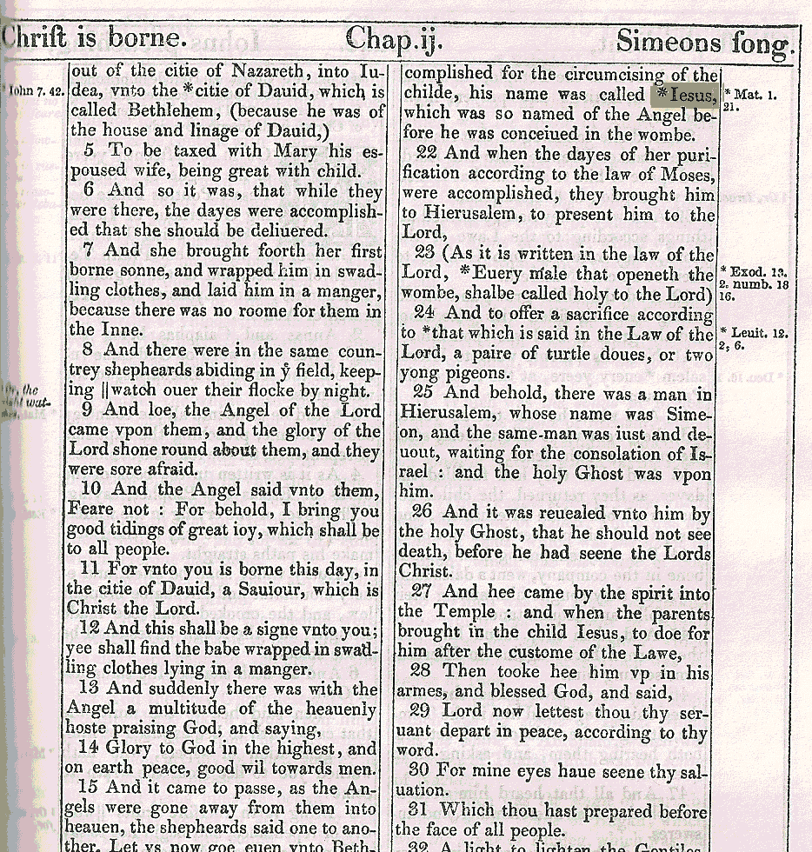
The word “Jesus” is not even in th[is early edition] 1611 KJV[, even though the historical record shows that the letter “J” had been introduced by then.]

If you look up the name “Jesus” in a Strong’s lexicon it has “Iesous”:
“2424 Iesous ee-ay-sooce’ of Hebrew origin (3091); Jesus (i.e. Jehoshua), the name of our Lord and two (three) other Israelites:–Jesus.”
Notice that it traces the name of Messiah to Hebrew word #3091 in the Strong’s lexicon. This name is the same name as “Joshua, Son of Nun”. In the Hebrew, this name is spelled עשוהי. The Greek alphabet simply lacks the letters necessary to correctly convey how the name is pronounced in Hebrew.
So how is the name pronounced? This will take some study. After all, we are English speakers so it is going to take a certain amount of concentration and diligence to try and understand how a Hebrew word is pronounced. …

Yehoshua
In the Strong’s concordance and other Hebrew Lexicons, the pronunciation listed for the Messiah’s name is typically “Yehoshua.” While I do not believe we should be getting all of our Hebrew learning from a Strong’s lexicon alone (that would be dangerous), most of us do own a Strong’s Concordance so I will be using it during this study for the purposes of illustration.
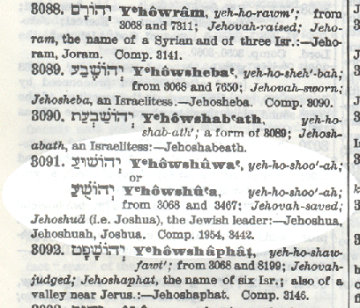
The reason for the “Yehoshua” pronunciation is due to the Hebrew vowel pointing added by the Masorite scribes. The vowel points are the little dots and dashes under and above certain Hebrew letters. Unlike English, Hebrew was written with mostly all consonants. It was up to the reader to supply the vowels in each word based on the context of the word.
The Masorites were concerned that Hebrew was becoming a lost language so they invented the vowel point system to preserve the sounds of the Hebrew language. However, in keeping with tradition[,] they were concerned that someone might accidentally mispronounce the letters that followed והי. Thus, they pointed והי to produce the same sound seen in “Yehovah.”
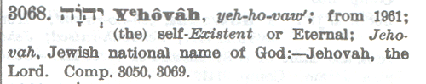
To avoid speaking the Heavenly Father’s name, the Jewish tradition was to say “Adonai” (“Lord”) instead of Yah[u]weh. For this reason, our English bibles also say “LORD” instead of “Yah[u]weh”. So rather than supplying the true vowels of the Heavenly Father’s name, the scribes inserted the vowels for “Adonai” so that the reader would be reminded to say “Adonai” rather than Yah[u]weh.
But what if the Hebrew Scriptures contained a phrase such as “Adonai Yah[u]weh” (Master Yahweh)?
They would then have to say “Adonai Adonai” … Their solution was to put the vowel points for “Elohim” within the Heavenly Father’s name so that they would be reminded to say “Adonai Elohim” instead of “Adonai Adonai”.
This is even mentioned in the Strong’s lexicon and it lists it as a different word number. Read what it says:
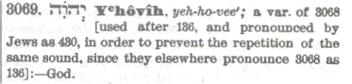
“136” is the Hebrew word “Adonai” and “430” is the Hebrew word “Elohim”. So these vowel points are used within the Father’s name whenever His name follows 136 (Adonai). And they pronounce this as 430 (Elohim) to avoid having to say Adonai twice.
For this reason, many English translations will render “Adonai Yah[u]weh” as “the Lord GOD” with “GOD” being in all capitals to let the reader know that this is where the sacred name is found in the Hebrew.
Very few even know that this is why “GOD” is sometimes in all capital letters (See Gen 15:2 for one of hundreds of examples of this). It is amazing how far men will go in order to cleave to tradition!
So how does this relate to the pronunciation of the Messiah’s name?
Let’s take a look at His name again in the Strong’s Lexicon:
Notice that there are other names listed in the Strong’s Concordance which contain the first three letters of Yah[u]weh’s name. And just like Yah[u]weh’s name, which starts with the “Yeho” vowel points, they use the “Yeho” vowel points in “Yehoram”, “Yehosheba”, “Yehoshaphat” and numerous other names which contain the first part of Yah[u]weh’s name.
Consistently, the scribes did not want anyone to accidentally pronounce the Heavenly Father’s name when saying these other names, so they changed the vowel points of names that began with והי.
Interestingly, they did not change the pronunciation of these same three letters when it was at the end of a person’s name. For instance, look at how Zechariah’s name is presented in the Hebrew text:
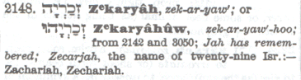
Notice the different vowel pointing and pronunciation herein (“ZecharYahu“).
There were no concerns by the scribes that His name would accidentally be pronounced when there were no Hebrew letters that followed after והי and so they provided the correct vowels.
Phonetically, the first three letters in the Heavenly Father’s name are pronounced “Yahu”. For this reason, the Heavenly Father’s name can be written as “YAHUeh” or “YAHWeh” and the same pronunciation will result, just as the word “Persuade” could also be spelled “Perswade”.
I prefer to use a W so that there is less confusion over how the name is to be pronounced. For if I wrote His name as “Yahueh” most readers would pronounce[/overemphasize] the ‘hu’ part of His name as ‘hoo,” and this is not how I believe the Father’s name was pronounced.
So the scribes had no problem giving the correct pronunciation of these three letters at the end of a name. Because it ends in ‘Yahu’, there was considered to be no risk in accidentally saying “Yahueh/Yahweh”. This would also explain why the scribes used the correct vowel points in the shortened form of Yahweh’s name (“Yah”):
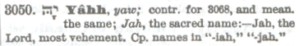
They even used the correct vowel pointing in “HalleluYah” and even the Greek New Testament properly transliterates this phrase as “HalleluYah” (See Strong’s Lexicon #239).
Thus, the only time they would revert to the “Yeho” pronunciation of these three letters was when it was at the beginning of a Hebrew name.
Personally, I want nothing to do with the unscriptural tradition of saying “Adonai/Lord/Elohim/God” in place of Yahweh [when YaHWeh is the word is presented there in the text].
Having said this, there are some Hebrew students and scholars who have noticed that a natural progression of Hebrew language is to shorten initial vowels whenever an accent is on the later syllables of Hebrew words. This tendency is said to result in the “Y’hoshua” or “Yehoshua” pronunciation. For this reason, some believe “Yehoshua” to actually be the correct pronunciation.
But while this may be true in some Hebrew words, there is evidence to support that this was not necessarily true in ancient times. At a minimum, it may have not been true in personal names containing the name of our Heavenly Father.
During times before the “Rabbis” came to prominence, Yahweh’s name was considered to be very important to pronounce. And ancient evidence suggests that they did not shorten or eliminate the sounds in Yahweh’s name.
Cuneiform tablets (also containing vowels) were discovered near the Ishtar gate in Babylon, which give a list of workers and captives to whom rations were given. Cuneiform scripts contain vowels. In addition to validating the biblical account in 2Kings 25:27-29 where it mentions that Jehoiachin (Yahuiachin) ate at the king’s table, these tablets help to establish the way these names were pronounced before the Masorite scribes inserted their vowel pointing, based on tradition:
“Yaukin, king of the land of Yahud,” (“Jehoiachin, the king of the land of Judah”)
The New Unger’s Bible Dictionary
Also, a family of Jewish businessmen living in the Mesopotamian city of Kippur in the fifth century BC left behind a collection of clay tablets recording their commercial transactions. The clay tablets, known as the Murashu documents, contain vowels and list the names of about 70 Jewish settlers in Persia. The Hebrew names which begin with והי (Yod Heh Waw) are all written “Yahu-” and never “Yeho”.
“In the cuneiform texts Yeho [YHW], Yo [YW] and Yah [YH] are written Yahu, as for example in the names Jehu (Yahu-a), Jehoahaz (Yahu-khazi) and Hezekiah (Khazaqi-yahu)” A. H. Sayce in “Higher Criticism” on p. 87
“The evidence from the Murashu documents thus corresponds to that from other sources: After the Exile, the ordinary form of the divine name used as an initial theophorous element was yahu”
“Patterns in Jewish Personal Names in the Babylonian Diaspora” JSJ, Vol. 4 Issue 2 Pg. 188
Notice that not only were names beginning with “Yeho” written as “Yahu”, but also names beginning with “Yo” such as “Yochanan” (John) and “Yoel” (Joel) were written as “Yahu”. This indicates John and Joel were originally pronounced “Yahuchanan” and “Yahuel”.
A third witness is found in an inscription of the Assyrian monarch Tiglath-pileser III (Gressmann Bilder 348; ANET 282a). When listing those kings who were paying tribute to this Assyrian King, it mentions “Yauhazi”, also known as “Ahaz”. Various lexicons, such as the New Brown-Driver-Briggs-Gesenius Hebrew-English Lexicon (p. 219 b) and the Hebrew Aramaic Lexicon of the Old Testament (under “Ahaz”), mention this inscription as well.
With all the evidence, it becomes clear that the name was never originally pronounced “Yehoshua”. Rather “Yahushua” is more correct and there is no reason to mispronounce the Heavenly Father’s name when speaking the name of His Son. Just as names which end with a reference to Yahweh correctly convey the Father’s name (“ZecharYah/ZecharYahu”), so do the names which begin with it.
[I think we are all agreed that the name “Yeshua” is not it, so I have skipped this section of the paper, but I am happy to share the file/link with those who may want to read that section.]

Yahusha
This form gaining in popularity fairly recently. However, it is easily proven to be incorrect.
Let’s examine the Strong’s Lexicon entry that represents the Messiah’s name again:
Notice in the Hebrew letters that there are two variant spellings of the Messiah’s name here. The first spelling has 6 letters עושוהי and the second spelling has 5 letters עשוהי. This is because both spellings are used in Scripture. The predominant spelling is עשוהי but the longer spelling is also found in Scripture.
Here are two places in the Masoretic Text where the longer spelling is employed:
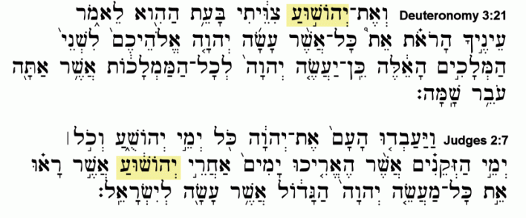
Deuteronomy 3:21- “And I commanded Joshua עושוהי at that time, saying, ‘Your eyes have seen all that Yahweh your Elohim has done to these two kings; so will Yahweh do to all the kingdoms through which you pass.
Judges 2:7- So the people served Yahweh all the days of Joshua, and all the days of the elders who outlived Joshua עושוהי, who had seen all the great works of Yahweh which He had done for Israel.
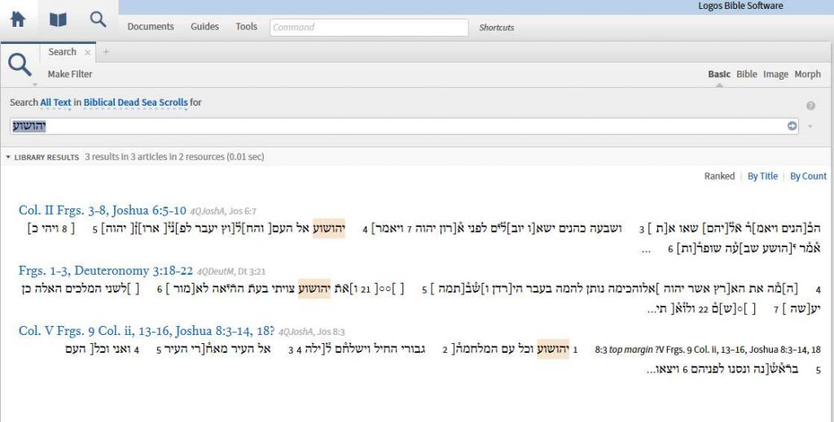

Dead Sea Scrolls Manuscript
As indicated above, the Dead Sea Scrolls manuscripts, shows the longer spelling is also found in the following verses:
Joshua 8:3 – So עושוהי arose and the whole army [rose up and marched on Ai. Joshua chose thirty thousand men], valiant warriors and he sen[t] them out [at night]. (4QJoshA, bracketed text missing from manuscript)
Joshua 6:7 – Then עושוהי [said] to the people, [“Go forward, march around the city, and let the armed guard march ahead of the ark of Yahweh”] (4QJoshA, bracketed text missing from manuscript)
The longer spelling is also found in Deuteronomy 3:21 of the Dead Sea Scrolls (4QDeutM). A fragment for Judges 2:7 was not found at all in the Dead Sea Scrolls so no one is able to know which spelling would have been used for that verse. (See image above of the Dead Sea Scrolls Manuscript.)
Variant spellings are common in Hebrew (especially in names) and usually the longer spelling is the older form and the newer spelling was the result of [the omission of] an extra letter that was not needed. Due to the fact that the Dead Sea Scrolls are older than the Masoretic text, and the longer spelling is more frequent in the Dead Sea Scrolls than the Masoretic text, it would appear to me that the longer spelling was the original.
I should like to hear what your thoughts are about the author’s reasoning here, family.
Because Hebrew does not need to have the extra “waw” ו to give us the “shua” sound (the Hebrew language does not always supply vowels), this would explain the shorter spelling. It does not mean that the shorter spelling represents [or necessitates/mandates] the pronunciation “Yahusha”; it simply means that the extra letter was unnecessary for one get the “shua” sound at the end of the name. To conclude that the shorter spelling must mean His name is also pronounced “Yahusha” ignores the fact that Hebrew words do not usually supply us with vowel sounds. It does supply us with all the vowel sounds in עושוהי but it does not NEED to.
Here is how each letter is pronounced:
י Yod – Produces a “Y” or “I” sound.
ה Heh – As a Hebrew vowel [sound,] it can produce the “ah” (like in #8283 “Sarah“). [The sound uttered may also be more like a breath.]
ו Waw – Also called “Vav”. As a Hebrew vowel letter it can produce an “oo” (u) sound like in #7307 Ruach [or “oh” sound].
ש Shin – Produces the “sh” sound. The following “oo” sound is indicated by a vowel pointing but Deut. 3:21 and Judges 2:7 actually gives us another “waw” after this letter, proving the “shu” pronunciation as valid. This is why Strong’s 3091 gives 2 possible spellings (see above lexicon graphic). This also eliminates “Yasha/Yahusha” and “Yahoshea/Yahushea” as being possibilities.
Thoughts?
ו Waw – Again, produces an “oo” (u) sound as in #7307 Ruach [or “oh” sound]. This is the ignored letter in the pronunciation “Yahusha.” As it is common that Hebrew words do not supply all the vowel sounds, this letter is not always used.
ע Ayin – Silent without a vowel point but indicates an “ah” sound at the end of “Yahushua”.
Those who use “Yahusha” will sometimes claim that “shua” can actually mean “riches.” This word “Shua” and the “riches” definition is found as Hebrew word #7769 in the Strong’s lexicon. But when you examine how the word “shua” is actually used in the Hebrew, it becomes evident that the Strong’s Lexicon may not be correct about that.
The word “shua” is only found in two verses, making it more difficult to determine the meaning. [It actually also appears as a name twice in the Scriptures (Gen 38:2, 12), and is spelled shin-uau-ayin. Very interestingly, its Strong’s # is 7770. The word/name is only defined, in this instance, as “father of Judah’s wife,” “a Canaanite.”]
The first is in Job 30:24:
Job 30:24- “Surely He would not stretch out His hand against a heap of ruins, If they cry out (“shua”) when He destroys it.
Obviously “Riches” would not be an appropriate meaning here. It sounds more like someone “crying out” to save them from destruction.
The Young’s Literal Translation reads it this way:
Job 30:24- Surely not against the heap Doth He send forth the hand, Though in its ruin they have safety (“shua”, salvation)
So the word could legitimately come from “yasha” and carry the meaning of “salvation.”
In the second instance, it is alluding to one trying to make their riches their salvation, saying Yahweh ultimately owns all the gold and has all the forces of power. Again, from the Young’s Literal Translation:
Job 36:19- Doth He value thy riches (shua, salvation)? He hath gold, and all the forces of power.
So it certainly is possible the “shua” is rooted in the verb “yasha.” The Strong’s word #3444 is pronounced “Yeshuah” but it is derived from #3467 “Yasha.” This shows that the “shua” sound can indeed be derived from the root word for salvation, “Yasha.” It’s just the Passive Participle form of “Yasha.” Thus, “shua” can also be derived from “yasha”
Therefore, “shua” might indeed legitimately be rooted in the Hebrew “yasha” meaning “save.”
For this reason, it seems plausible that “shua” in these instances may actually be rooted in the Hebrew word “Yasha.” In fact, the Theological Wordbook of the Old Testament makes a comment that “shua” could legitimately be derived from either “yasha” (save) or “shawa” (cry).
“Shua. Cry, if it is from shua; opulence, “relief” if it is from yasha “to save, deliver” (cf. BDB p. 447b and 1002b). The first meaning is likely in Job 30:24, though the second meaning cannot be ruled out”
So Lexicon writers don’t have assurance as to its meaning, and the Brown Driver Briggs Lexicon even says its “meaning is dubious.”
If you still aren’t convinced, consider the following points:
- The Aramaic form of Yahushua (as we discussed earlier) uses “Yeshua” עושי and just like עושוהי uses a “waw” ( ו ) to give us the “shoo” sound in “shua.” If the original Hebrew form were “Yahusha,” the Aramaic form of the same name would not have been pronounced “Yeshua” (#3442) to begin with. But the Aramaic form is found in the scriptures in 29 verses of inspired scripture (e.g. 1Chron 24:11, 2Chron. 31:15, Strong’s #3442). Where are they getting the “shu” in “Yeshua” if the Messiah’s name had no “shu” sound?
- The Greek form of the name “Iesous” gives us an “oo” sound at the end of the name. Since the “Iesous” form is found in the Septuagint, a translation of the scriptures into Greek that was completed 200 years before Messiah came, it shows that the “oo” sound existed at the end of Yahushua prior to the time that Yahushua came and died for our sins.
- The Masoretic Hebrew vowel points give us a “shua” ending in עושוהי and in עשוהי. That’s why all Hebrew lexicons give us the “shua” pronunciation in this name. The two spellings do not necessarily mean there are two different pronunciations. The vowel points under the Hebrew letters give us the “shua” ending with both spellings.
Thus, in spite of those who claim it cannot, the Messiah’s name can have the “shua” sound even though it is derived from “yasha” (meaning “salvation”) and there are clear examples in the Scripture where “Yahusha” would be an impossible rendition of the Messiah’s name.
So the pronunciation “Yahusha” can be proven wrong by simply looking at the Scriptures and knowing that in order to arrive at the “Yahusha” pronunciation, we would need to ignore the scriptures which clearly have a ו (oo sound) after the ש (sh sound).

Why use Yahushua?
Since we seek to walk in the truth, we should want to proclaim His name as Yahweh gave it. Some of this may seem confusing, but it’s rooted in the [unavoidable] fact that our Scriptures were written in a different language. For one who could speak the ancient language, no confusion would exist.
One thing is clear. Yahweh is the one who named His Son, and we simply have no business changing it. It is all these changes that have brought about the confusion. It can be complicated to sort through it all, but truth-seeking is an honorable thing that is pleasing in Yahweh’s eyes.
Of course, if we are somehow unable to pronounce the Messiah’s name, certainly Yahweh is able to show mercy. But if we are able to, what reason do we have to continue in error? It is better to cleave to what Yahweh gave rather than continuing in the traditions and mistakes of men. Continuing in error is never superior to walking in the truth.
Yahweh predicted what His Son’s name would be, so we have something we can look to for clarification. In the book of Zechariah, it states:
Zechariah 6:9- Then the word of Yahweh came to me, saying: 10 – “Receive the gift from the captives– from Heldai, Tobijah, and Jedaiah, who have come from Babylon– and go the same day and enter the house of Josiah the son of Zephaniah. 11 – Take the silver and gold, make an elaborate crown, and set it on the head of עשוהי (Yahushua) the son of Jehozadak, the high priest. 12 – Then speak to him, saying,`Thus says Yahweh of hosts, saying: “Behold, the Man whose name is the BRANCH! From His place He shall branch out, And He shall build the temple of Yahweh; 13 – Yes, He shall build the temple of Yahweh. He shall bear the glory, And shall sit and rule on His throne; So He shall be a priest on His throne, And the counsel of peace shall be between them both.”‘
Notice that this “BRANCH” would be both a Priest and a King. Obviously, this is not literally speaking of the man Yahushua, son of Yahuzadak.’ It is speaking of the Messiah, called “The Branch” who would be a Priest AND King. This was the role of the Messiah (Compare Psalm 110, Isaiah 9:6.). Another scripture mentioning the “BRANCH” is Jeremiah 23:5, and it’s clearly Messianic:
Jeremiah 23:5- “Behold, the days are coming,” says Yahweh, “That I will raise to David a BRANCH of righteousness; A King shall reign and prosper, and execute judgment and righteousness in the earth.
The same Hebrew word is used here so Zechariah 6 is a quite clear Messianic prophecy. So what we have in Zechariah is a prophecy of what the Messiah’s name would be called.
Zechariah was instructed to take a crown and place it on the head of Yahushua, the son of Yahutsadak (in the Hebrew it does not have “Yeshua” here, but rather “Yahushua” עשוהי). When placing the crown on the head of Yahushua עשוהי the High Priest, Zechariah was told to proclaim:
“Behold the man whose NAME is the BRANCH.”
Thus, this High Priest (Yahushua) had the same name as the coming Messiah who would reign as a [King and High P]riest on His throne. He had the NAME of the Messiah, and Yahweh predicted and revealed what the Messiah’s name would be through this beautiful object lesson. So why not call Him by that name?
Also, notice that it was not Moshe (Moses) who was able to bring the children of [Yisra’el] across the Jordan, but, rather, it took a man named Yahushua (Joshua) the Son of Nun to lead them across the Jordan and into the Promised Land. In this is a lesson, for Moshe can show us the right way to live [(the “How to …”),] but the Torah cannot save us [nor give us the “POWER to … live pleasing and acceptable to the Most High]. We need a man named Yahushua to lead us across the Jordan and into the Promised Land.
[There are numerous] examples [of] the first century believers who were proclaiming His name baptizing in His name; healing in His name; being persecuted for His name; etc. I say, let’s be willing to do the same by using the Messiah’s name as it is written and understood in Hebrew, a name that is proclaimed in the Torah and prophets, a name with a very important Hebrew meaning: עשוהי
Yahweh saves! YaHUaH saves! Yahweh is salvation! YaHUaH is salvation!
https://eliyah.com/pronunciation-messiahs-name/

